**Color versions of the photographs and map in the book**

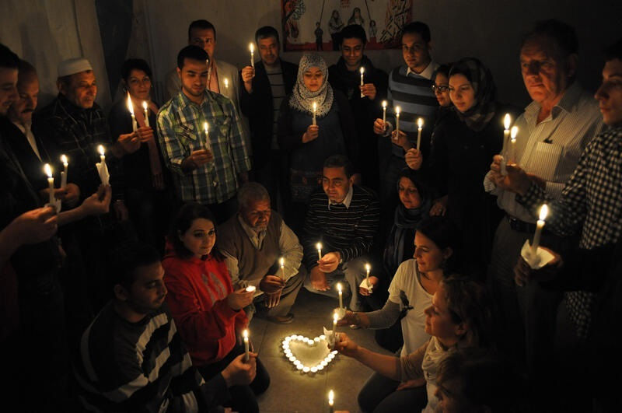

Figure 2.1. Local staff of Oxfam GB in Gaza holding a vigil on March 14th 2013 (with permission from Elena Qleibo, Oxfam GB Food Security and Livelihoods Coordinator, Gaza) (page 35)



Figure 5.1. An adult specimen of the Large Pine Weevil *Hylobius abietis*, infected with*Metarhizium anisopliae* fungus. Fluffy white fungal growth (mycelium) can be seen exuding onto the surface from infected internal organs. This pest, which is present across Eurasia, can wipe out conifer plantations and reforestation efforts. Conifers provide wood for cooking (and heating) for poor people in the northern part of North Korea (DPRK) for example, and hence directly enable human food security (photo: Tariq M Butt) (page 104)

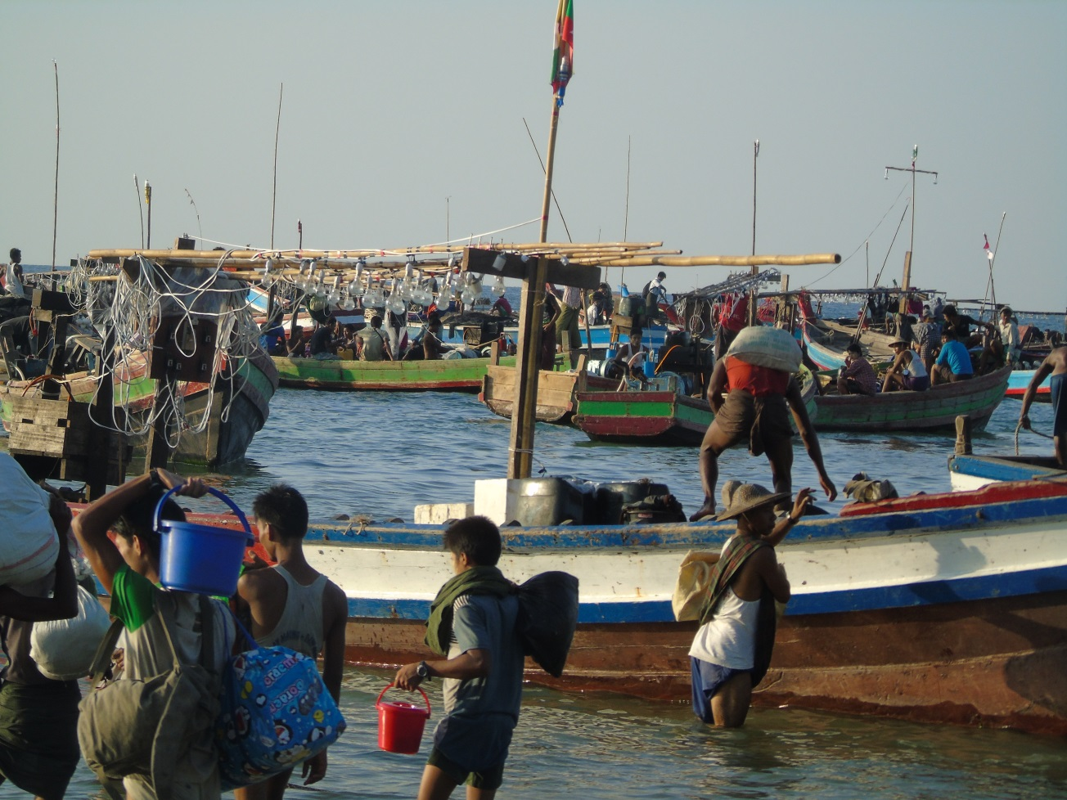

Figure 5.2. Activity at Gyeik Taw fishing village, Andaman sea coast, Myanmar (photo: Ulricht Schmidt) (page 108)

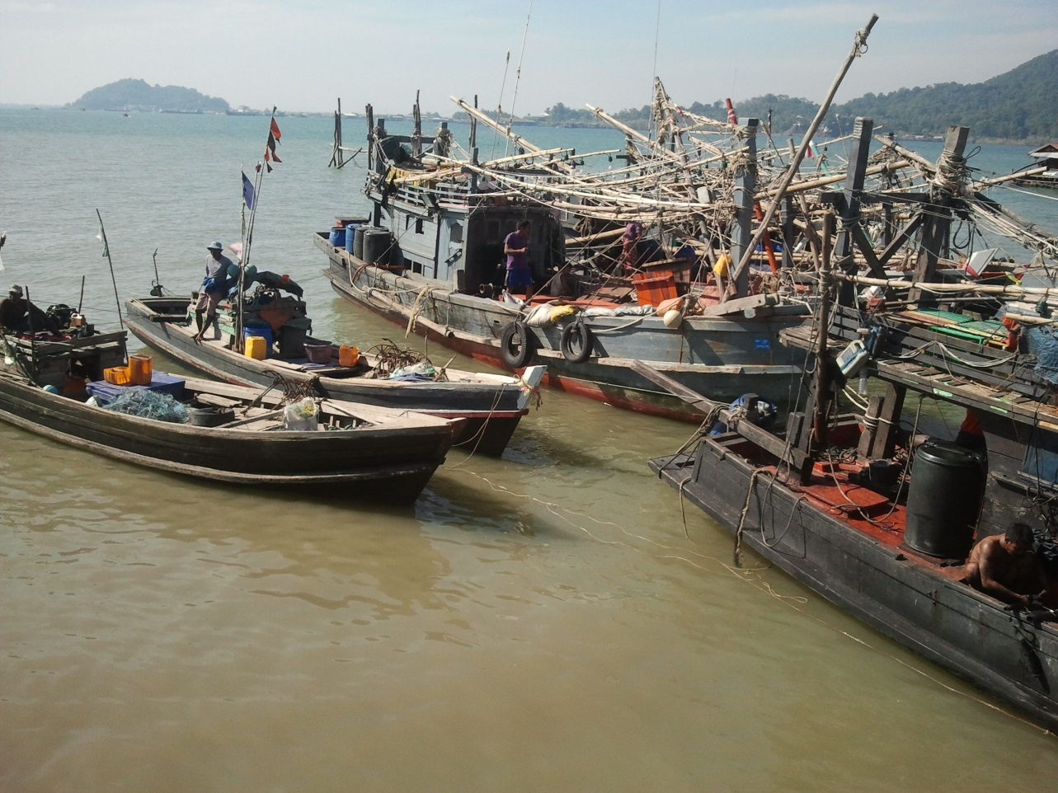

Figure 5.3. Fishing boats waiting to set off, Bay of Bengal coast, Thandwe district, Rakhine State, Myanmar (photo: Ulricht Schmidt) (page 109)

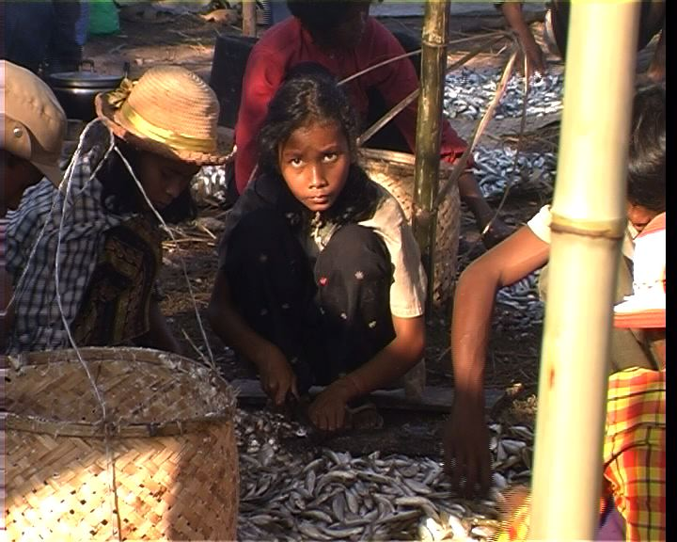

Figure 5.4. At the edge of Tonle Sap Great Lake, Cambodia. The start of the value chain, artisanal processing of fish to fish paste (photo: Peter Degen) (page 110)

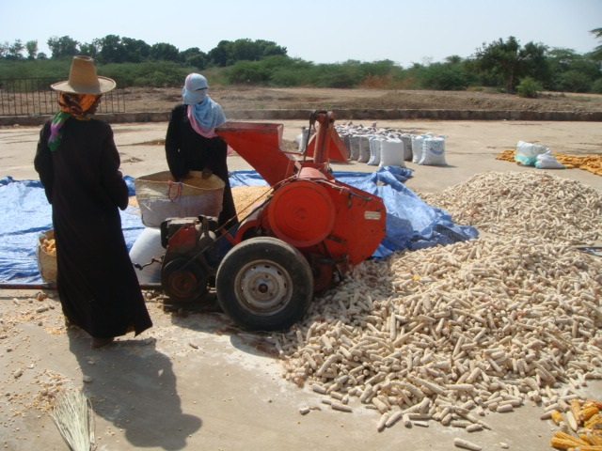

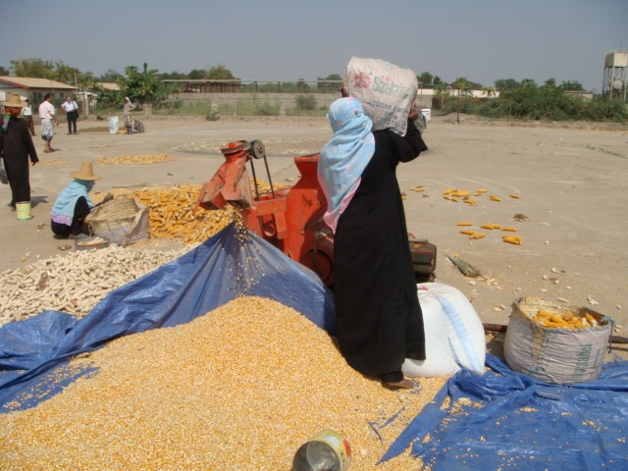

Figure 6.1. A mechanised sheller of corn cobs, easier and far quicker than hand shelling in Hoddaidah governorate Yemen, bulking improved seed for distribution to farmers as planting material (photos: Jafaar Hasan Alawi Al-Jeffri) (page 149)



Figure 6.2. African cities at risk due to sea level rise [reproduced with permission of UN-Habitat (2014)] (page 182)